**Project Proposal Of Software Lab**

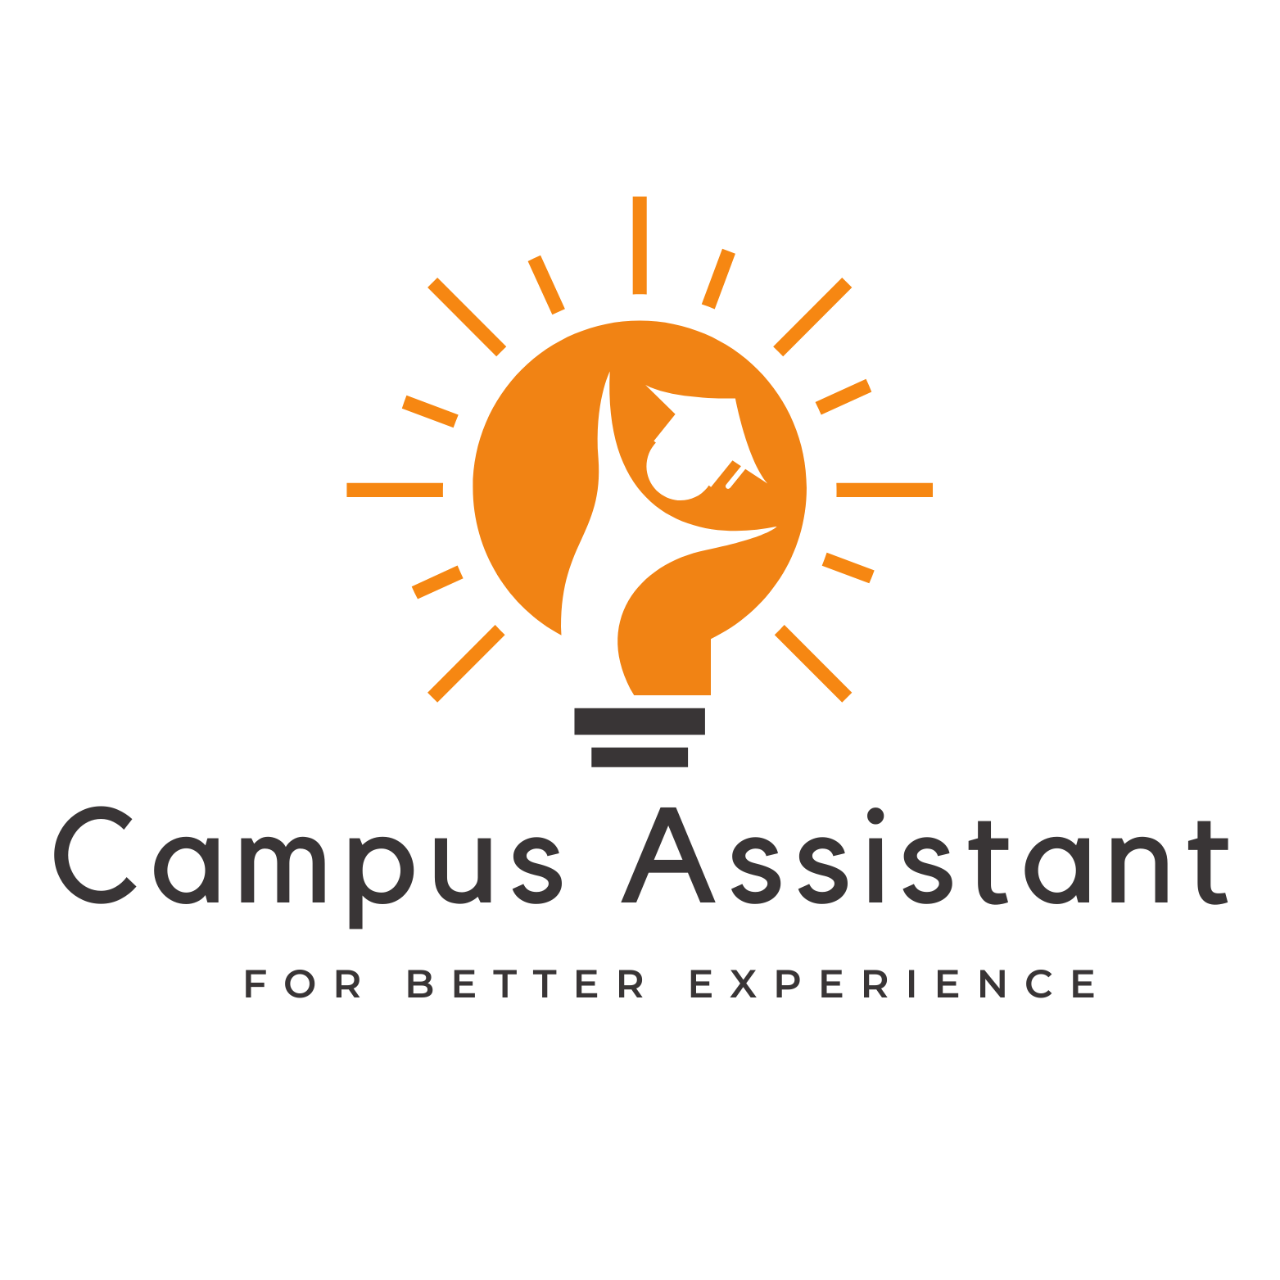

Team Master Molecules

1. Sayed Hossain Jobayer (011201062)

2. Md Shaharia Hossen (011201288)

3. MD Mehedi Hasan (011201292)

4. Khan Mohammad Emon (011201394)

5. Nusrat Akter (011201407)

3 March 2024

**Summary:**

This project's main goal is to launch a ground-breaking smartphone application that will improve and streamline campus life. Focusing on difficulties relating to education, the app will offer creative ways to make assignments easier for pupils. One of the primary advantages is an easy-to-use system for scheduling courses that makes it simple to organize and oversee academic schedules, allowing students to get through their classes without undue difficulty. The app will also have smart notification capabilities that will help users stay organized and on top of their duties by acting as reminders for important tasks, deadlines, and activities.

**Motivation:**

The inspiration behind this project stems from a genuine desire to alleviate the complexities often associated with campus life. Recognizing the myriad challenges faced by students in managing their academic commitments, schedules, and important dates, the motivation is to harness technology to create a comprehensive solution. The goal is to empower students with a user-friendly mobile app that not only simplifies their educational journey but also contributes to an overall improved campus experience.

**Problem-Solving:**

The project addresses the intricacies of campus life by tackling specific points. The course scheduling feature eliminates the tedious process of manually organizing class routines, allowing students to plan their academic activities effortlessly. The integration of smart notifications directly addresses the issue of forgetfulness by serving timely reminders, ensuring students never miss essential tasks or deadlines. Through these solutions and more, the project aims to enhance the efficiency and experience of students navigating the complexities of campus life.

**Introduction:**

In this project, we are going to implement a revolutionary project to make campus life easier. Our mobile app will do several tasks that will solve multiple problems that are linked to campus life. For example, the course scheduling feature will help students do the course routine easily and without hassle. Our mobile app will notify users, which will help them remember the important task. We are going to use Firebase for handling data. For security purposes, we are going to use authentication.

**Tech Stack & Architecture:**

**ERD Diagram:**

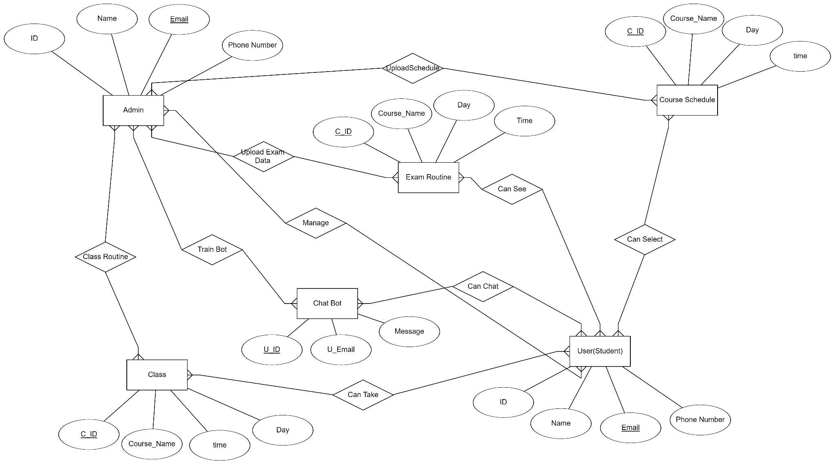

**Schema Diagram:**

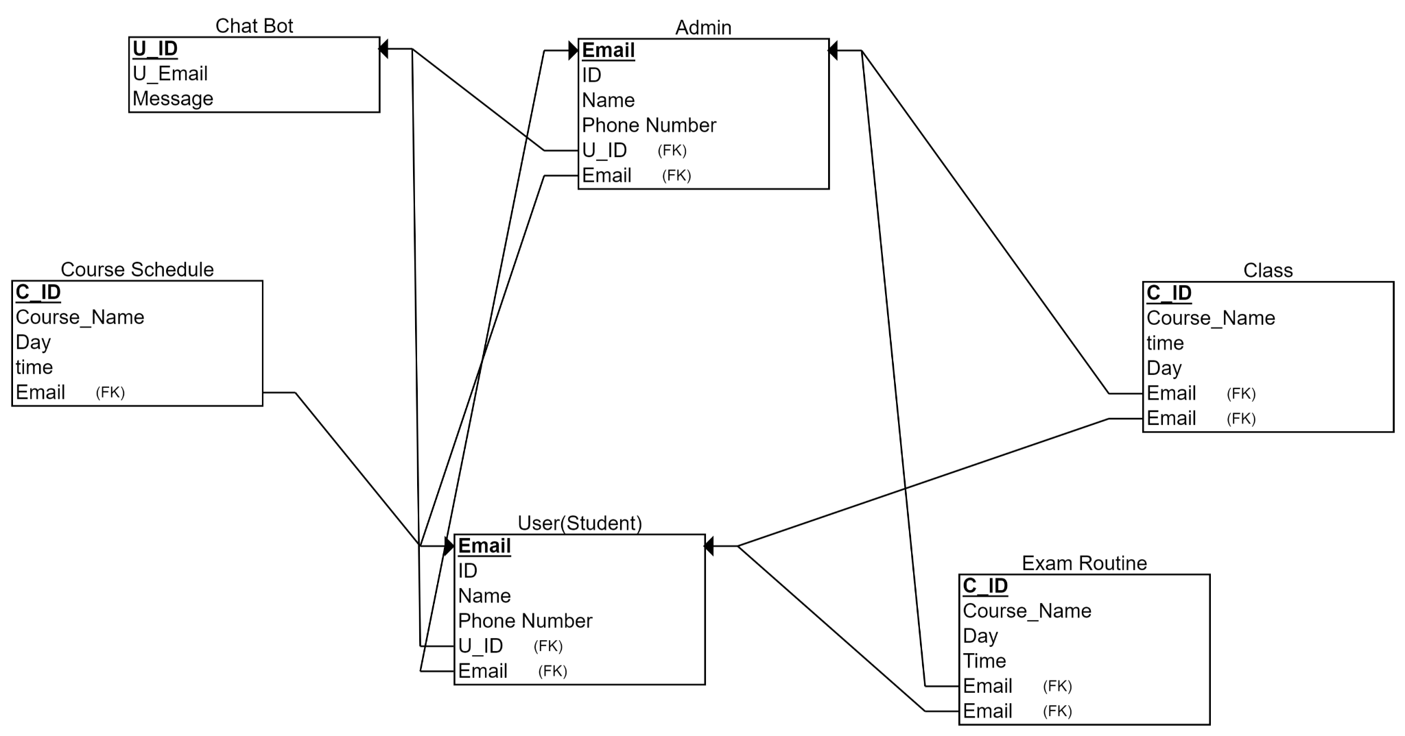

**Tech Stack:**

Frontend: Flutter framework with Dart language for the cross-platform user interface.

Backend: Firebase for the server-side application.

Database: Firebase Firestore for storing and managing data.

Authentication: Firebase Authentication for secure user authentication.

Containerization: Although Docker is not utilized in this case, the Firebase platform inherently handles deployment and scaling.

**Features :**

* Course Schedule
* Exam Routine / Room No Show
* Class Time / Room No extracted from user manually or automatically
* Qus Bank with better filtering system
* Chat bot for queries
* Web Scarping for Notices

**Basic Data Flow:**

1. A user interacts with the Flutter front end, triggering a request.

2. The front end communicates with the Firebase backend through Firebase SDKs and APIs.

3. Firebase services handle the request, including authentication using Firebase Authentication.

4. Firebase Firestore is used for data storage and retrieval, replacing the MongoDB database.

5. The serverless architecture of Firebase manages backend operations, eliminating the need for explicit microservices.

6. Containerization is not required as Firebase handles deployment and scaling automatically, ensuring consistency across different environments within the Firebase platform.

This adapted tech stack and architecture align with the use of Flutter and Firebase, providing a robust and scalable foundation for our project's goals.

**Future Plan:**

Our Plan is to implement video lecture library inside our app for learning platform